SWT 22022 – Practical for Internet Application Development
Department of Information and Communication Technology
Faculty of Technology
Lab sheet :17
Reg. Number: SEU/IS/20/ICT/084
Academic Year :2020/2021
Date: 2024.10.21
Practical No :17

Title: Introduction to React and Basic Functional Components
Aims:

- Setting up development environment
- Project creation
- Understanding the core concepts
Tasks:

- Install Node.js and npm
- Setting up React
- Start the development server
- Basic React Components

Activities :

1. Install Node.js and npm

Windows:
- Download the appropriate Node.js installer from the official website:
htps://node.js.org/en/download/

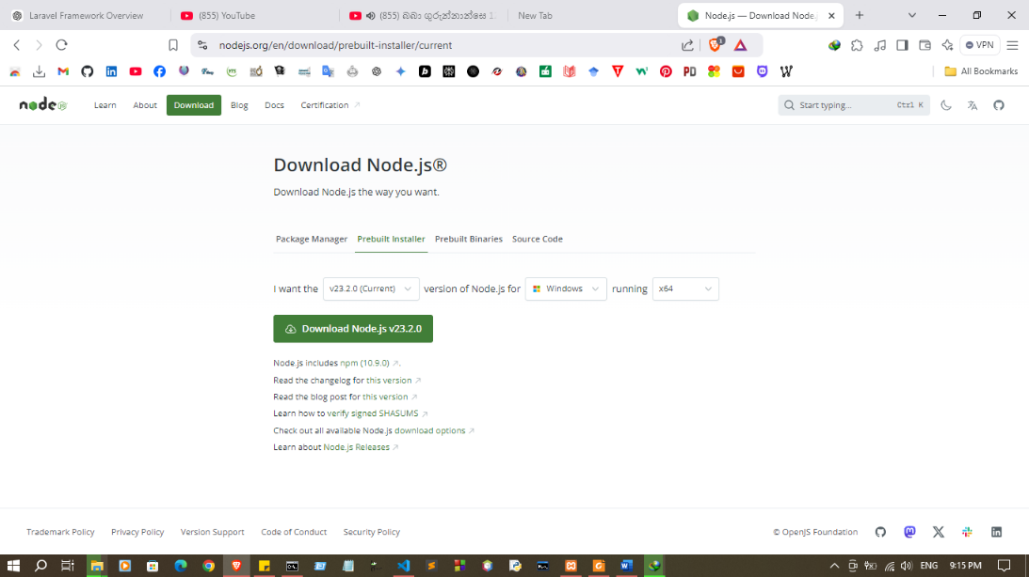
- Run the downloaded installer file and follow the on-screen instructions.

- Verify the installation by opening a command prompt and typing

node -v and npm -v
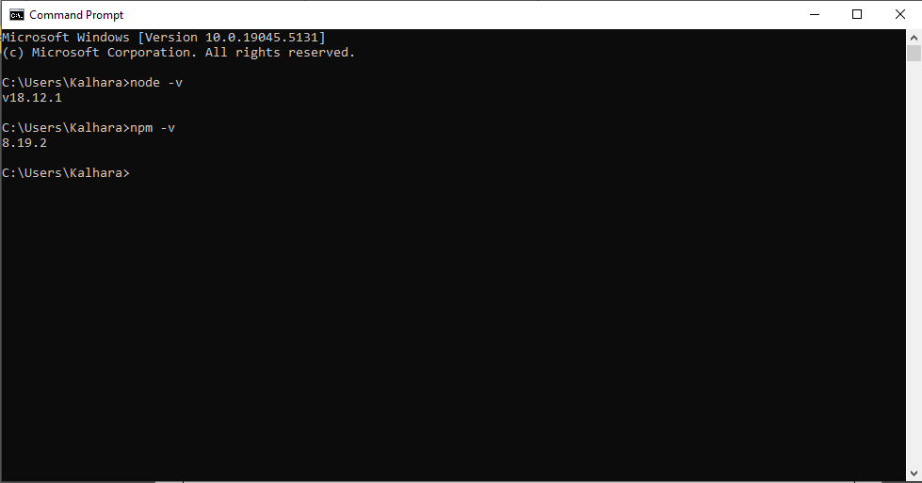

macOS:
- Install Homebrew if you don't already have it: htps://docs.brew.sh/Installation
- Once Homebrew is installed, run the following command to install Node.js:
brew install node
- Verify the installation by opening a Terminal window and typing

node -v and npm -v

Linux:
- The installation method for Linux depends on your specific distribution. However, generally, you can use your package manager to install Node.js. For example, on Ubuntu, you can use the following command:
sudo apt install nodejs npm
- Verify the installation by opening a terminal window and typing

node -v and npm -v

- Setting up React

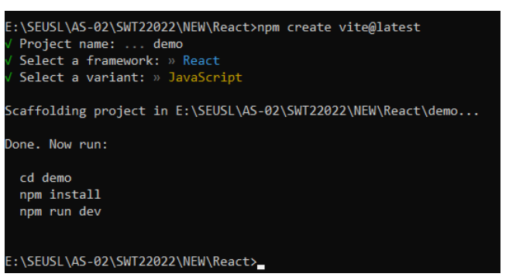
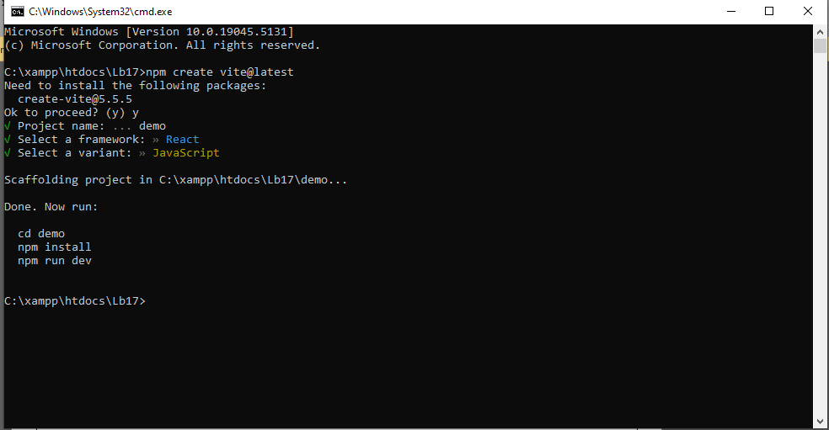

- Start the development server

Install the required dependencies for the project:
npm install
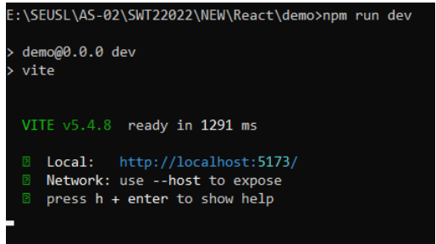
Run the development server:
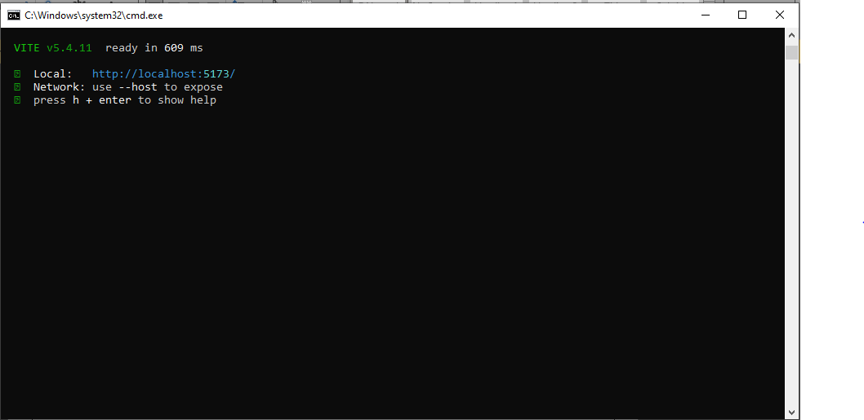

- Basic React Components

Hello.jsx

function Hello() {
return (
<>
<div>
<h2>Hello World !</h2>
</div>
</>
)
}
export default Hello

main.jsx

import { StrictMode } from 'react'
import { createRoot } from 'react-dom/client'
// import App from './App.jsx'
import './index.css'
import Hello from './hello.jsx'
createRoot(document.getElementById('root')).render(
<StrictMode>
<Hello />
</StrictMode>,
)

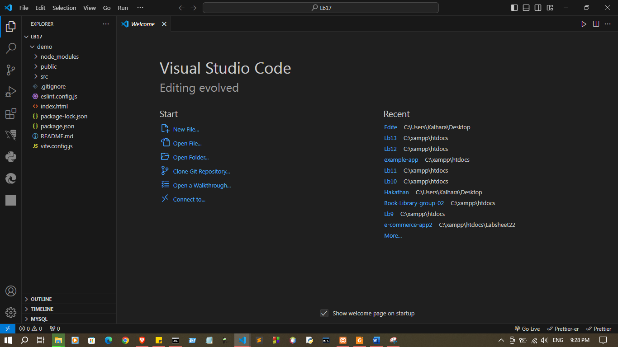

Hello.jsx
function Hello() {
return (
<>
<div>
<h2>Hello World !</h2>
</div>
</>
)
}
export default Hello

App.jsx

import { StrictMode } from 'react'
import { createRoot } from 'react-dom/client'
// import App from './App.jsx'
import './index.css'
import Hello from './Hello.jsx'
function App() {
return (
<>
<StrictMode>
<Hello />
</StrictMode>,

</>
)
}
export default App

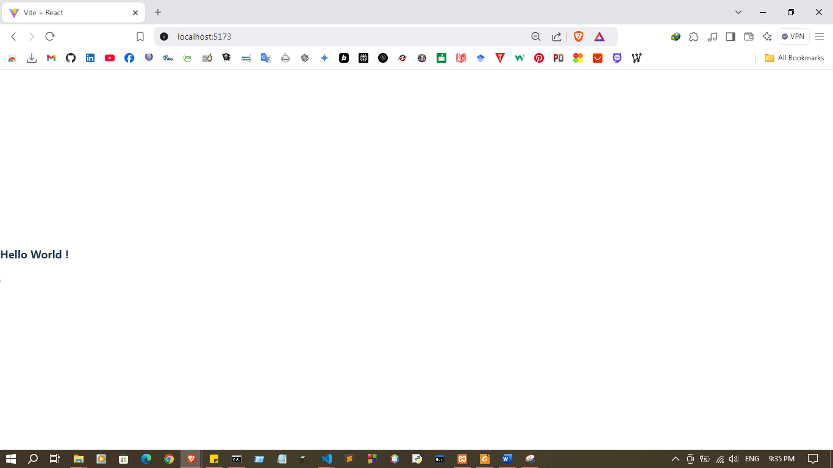

Discussion:

- This lab session introduces React, a popular JavaScript library for building user interfaces, with a focus on basic functional components. It starts with setting up the development environment by installing Node.js and npm, which are essential tools for running and managing React projects. Participants will then learn to set up a React application and start the development server to view real-time updates as they build. The session emphasizes understanding React’s core concepts, such as components, props, and the virtual DOM, while creating and working with basic functional components. By the end of this session, students will have a foundational understanding of how to structure and develop a React project effectively.

